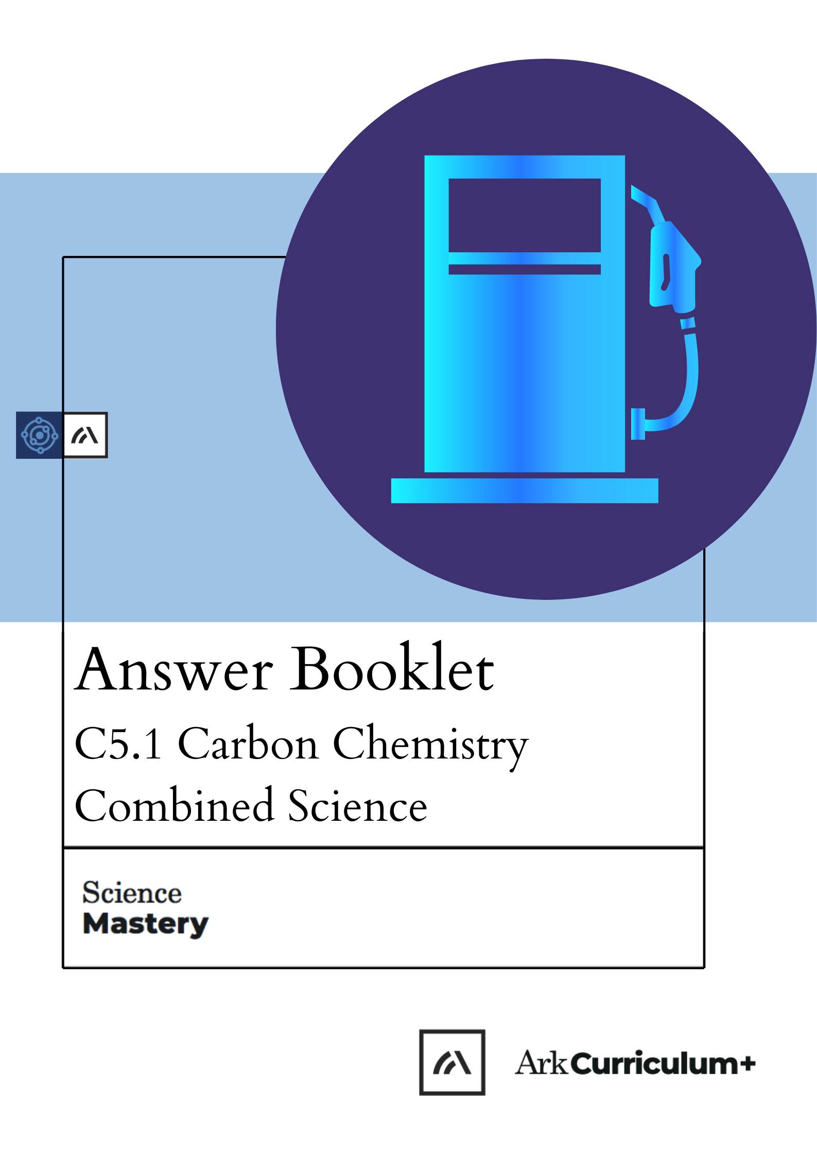


The Big Idea

Carbon Chemistry
What is crude oil actually made from? Why is so useful? How can we separate it and use it for different things? How is crude oil related to petrol and other fuels?

Organic chemistry is the study of the structure and properties of compounds that contain carbon. One of the biggest sources of carbon compounds is crude oil, which can be separated into many different compounds called hydrocarbons. Humans use these hydrocarbons for many different purposes.
This is the sixth unit we are studying as part of the big idea: Structure Determines Properties.

In this unit we will learn about what crude oil is and how it can be separated into different useful products. We will learn about different groups of hydrocarbons that can be obtained by fractional distillation of crude oil and the properties of these compounds and the different reactions they are involved in. We will also look at how some of these products can be made into useful polymers.

Chemistry students will also look at other groups of compounds, including alkenes, alcohols and carboxylic acids and reactions involving these compounds.

We will develop our skills in this unit by practising drawing models of covalent bonding in molecules. We will also revisit distillation as a method of separating a mixture based on the boiling points of the substances in it.
TASKS:
What subject will this unit focus on? BIOLOGY CHEMISTRY PHYSICS
(circle the correct subject)
There are lots of keywords underlined above. List these into the two columns:
Words I know | Words I haven’t seen before
To answer before the unit:
- What are you most excited to learn about in this topic?
_____________________________________________________________________________________________________________________________________________________________________________________________

- What do you already know about this topic?
_____________________________________________________________________________________________________________________________________________________________________________________________

- Why do you think it’s important to learn that structure determines properties?
______________________________________________________________________________________________________________________________

- What knowledge from previous science lessons might help us?
_____________________________________________________________________________________________________________________________________________________________________________________________

- What questions do you have about this topic?
______________________________________________________________________________________________________________________________

To answer at the end of the unit:

- Tick off any words in the ‘words I haven’t seen before’ column that you are now confident with. Circle any you still need more practice to use.

- What have you most enjoyed about this unit?
_____________________________________________________________________________________________________________________________________________________________________________________________

- What more would you like to learn about bonding as part of the big idea: ‘Structure Determines Properties’?
______________________________________________________________________________________________________________________________

Pre-Test

- The atomic structure of elements relates to their position on the Periodic Table.
In which group of the Periodic Table would you find the element represented by this electronic configuration? [1]
Tick ( ) one box.
- Group 2 | 
- Group 3
- Group 1

- Which is the correct definition of a compound?

Tick ( ) one box. [1]

- Two or more elements mixed together
- Two or more elements chemically bonded together
- A group of non-metal atoms bonded together

- Which is the correct definition of a molecule?

Tick ( ) one box. [1]

- A group of metals atoms bonded together
- A group of metal and non-metal atoms bonded together
- A group of non-metal atoms bonded together

- Which type of bonding would be found in a molecule of oxygen?

Tick ( ) one box. [1]

- Covalent
- Ionic
- There would be no bonding
- Which type of bonding would be found in sodium chloride?

Tick ( ) one box. [1]

- Covalent
- Ionic
- Metallic
- Which statement is true of covalent substances?

Tick ( ) one box. [1]

- They contain non-metal atoms
- They contain metal atoms
- They contain metal and non-metal atoms
- What type of atoms make up both diamond and graphite?

Tick ( ) one boxes. [1]

- oxygen
- hydrogen
- carbon
- copper

- Choose the correct electronic configuration of a carbon atom.
The atomic number of carbon is 6. [1]
Tick ( ) one box.
- 2,4
- 2,2,2
- 2,8
- Choose the best explanation for why noble gases are unreactive. [1]
Tick ( ) one box.
- They all have 8 electrons in their outer shell
- They have a stable electron arrangement
- They are neutral because they have equal numbers of protons and electrons
- Define ‘polymer’.
Tick ( ) one box. [1]
- A polymer is a type of plastic
- A polymer is a long chain molecule made up of many units
- A polymer is a type of plastic that melts when heated

End of Unit Pre-Test. Turn over to see the answers. Give yourself a mark out of 10.

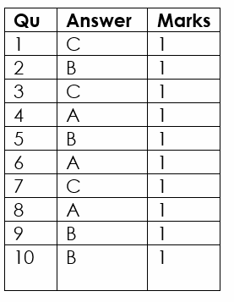

Crude Oil and Hydrocarbons
Knowledge Organiser
- Crude oil is a finite resource found in rocks.
- Crude oil is the remains of an ancient biomass consisting mainly of plankton that was buried in mud.
- Crude oil is a mixture of a very large number of compounds. Most of the compounds in crude oil are hydrocarbons.
- Hydrocarbons are molecules made up of hydrogen and carbon atoms only.
- Most of the hydrocarbons in crude oil are hydrocarbons called alkanes.
- The general formula for the homologous series of alkanes is C_{n}H2_{n+2}
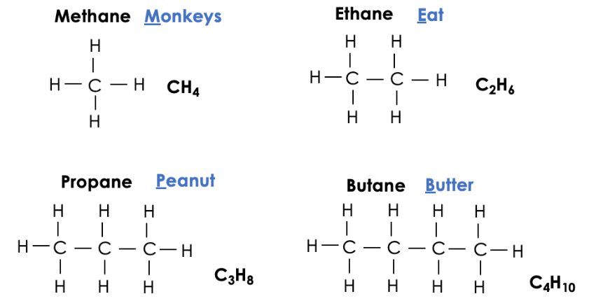
- The first four members of the alkanes are methane, ethane, propane and butane.
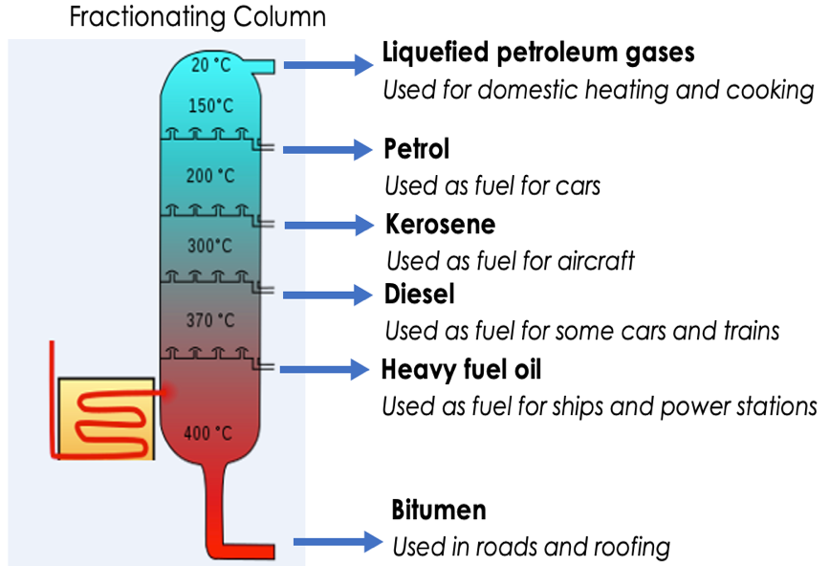
- Many useful materials on which modern life depends are produced by the petrochemical industry, such as solvents, lubricants, polymers, detergents.
- The vast array of natural and synthetic carbon compounds occur due to the ability of carbon atoms to form families of similar compounds.
Fractional Distillation
- The many hydrocarbons in crude oil may be separated into fractions, each of which contains molecules with a similar number of carbon atoms, by fractional distillation.
- The fractions can be processed to produce fuels and feedstock for the petrochemical industry.
- Many of the fuels on which we depend for our modern lifestyle, such as petrol, diesel oil, kerosene, heavy fuel oil and liquefied petroleum gases, are produced from crude oil.
- During fractional distillation, a fractionating column is used. This column has condensers at varying heights.
- A fractionating column is hot at the bottom and cooler at the top
- Substances with high boiling points condense at the bottom and those with low boiling points condense at the top
- During fractional distillation, crude oil is evaporated. It's vapours condense at different temperatures in the fractionating column.
- Each fraction produced during fractional distillation has a similar number of carbons (or size of hydrocarbons)
- Some properties of hydrocarbons depend on the size of their molecules, including boiling point, viscosity and flammability. These properties influence how hydrocarbons are used as fuels.
- Boiling point, viscosity and flammability change with increasing molecular size.
Combustion of Hydrocarbons
- The combustion of hydrocarbon fuels releases energy.
- During combustion, the carbon and hydrogen in the fuels are oxidised.
- The complete combustion of a hydrocarbon produces carbon dioxide and water.
- The general word equation that describes the complete combustion of an alkane is:
alkane + oxygen carbon dioxide + water
- Complete combustion reactions of alkanes can be represented by balanced symbol equations, for example:
CH₄ + 2 O₂ CO₂ + 2 H₂O
- Incomplete combustion can occur if there is not enough oxygen. In this case, carbon, carbon monoxide are produced.
Cracking
- Hydrocarbons can be broken down (cracked) to produce smaller, more useful molecules.
- Cracking can be done by various methods including catalytic cracking and steam cracking.
- The products of cracking include alkanes and another type of hydrocarbon called alkenes.
- Alkenes are more reactive than alkanes and react with bromine water, which is used as a test for alkenes.
- If alkenes are present, the bromine water will turn from orange to colourless.
- Alkenes are used to produce polymers and as starting materials for the production of many other chemicals.
- There is a high demand for fuels with small molecules and so some of the products of cracking are useful as fuels.
Polymers
- Polymers have very large molecules. The atoms in the polymer molecules are linked to other atoms by strong covalent bonds.
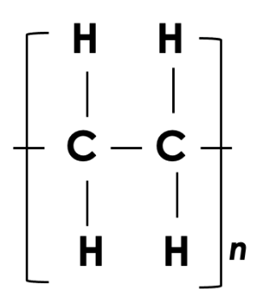
- Polymers can be represented in the form:

where n is a large number

- The intermolecular forces between polymer molecules are relatively strong and so these substances are solids at room temperature.
- The properties of polymers depend on what monomers they are made from and the conditions under which they are made. For example, low density (LD) and high density (HD) poly(ethene) are produced from ethene.
- Thermosoftening polymers melt when they are heated.
- Thermosetting polymers do not melt when they are heated.

Glossary
Alkane | A hydrocarbon molecule with the general formula C_{n}H_{2n+2.}  Methane, ethane and propane are all alkanes.
Alkene | A hydrocarbon molecule with the general formula C_{n}H_{2n.}  Alkenes contain a carbon-carbon double bond.
Amino acid | A naturally occurring monomer that contains two different functional groups.  Amino acids can be joined together to make polypeptides and proteins.
Catalyst | A substance that speeds up a chemical reaction without being used up.  Ethanol can be made from ethene, but this requires a catalyst.
Combustion | A reaction where a substance burns in oxygen.  Combustion of alkanes produces carbon dioxide and water.
Covalent bonding | The type of bonding found between non-metals, where electrons are shared to provide full outer shells.  Covalent bonding is found in both covalent molecules and giant covalent structures.
Cracking | The process by which longer hydrocarbon chains are broken down into shorter hydrocarbons.  Cracking produces an alkane and an alkene.
Crude oil | A finite resource found in rocks made from the ancient biomass of plankton.  Crude oil is a non-renewable resource that is used to provide fuels and make plastics.
Fractional distillation | The process by which crude oil is separated into groups of similar compounds based on their boiling points.  During fractional distillation, crude oil is evaporated and fractions condense at different temperatures.
Functional group | An atom or group of atoms that is responsible for the chemical properties of a compound.  Alcohols, alkenes and carboxylic acids all contain a functional group.
Homologous series | A group of compounds that have similar chemical properties and the same general formula.  The alkanes are a homologous series that all have the general formula C_{n}H_{2n+2}.
Hydration | A process which adds water.  Alcohols can be made from alkenes by hydration.
Hydrocarbon | A molecule that contains carbon and hydrogen atoms only.  Alkenes and alkanes are hydrocarbons.
Intermolecular forces | Attractive forces that hold molecules of a substance together.  Covalent molecules have low melting and boiling points because little energy is required to overcome the intermolecular forces.
Molecule | A small group of non-metal atoms chemically joined together  There are millions of molecules of water in a swimming pool.
Monomer | A repeating subunit used to make a polymer.  Glucose is the monomer that makes up starch (a polymer).
Physical property | A property of a substance that can be observed at any time  A physical property of iron is that it is hard.
Polymer | A substance made up of repeating subunits (monomers).  Plastic is a polymer.
Saturated | A compound that contains only carbon-carbon single bonds.  Alkanes are saturated as they contain only single bonds between carbon atoms.
Thermosetting | Polymers that do not melt when they are heated.  A thermosetting plastic’s shape cannot be changed.
Thermosoftening | Polymers that melt when they are heated.  The shape of a thermosetting plastic can be changed when it is heated.
Unsaturated | A compound that contains one or more carbon-carbon double (or triple) bonds.  Alkenes are unsaturated as they contain a double bond between carbon atoms.
Viscosity | A measure of a substance’s resistance to flow or how easy it is to pour.  Water has a low viscosity, so is not very viscous, but honey has a high viscosity and is very viscous.

Do Now
Prior Knowledge Review
- State the chemical symbol for carbon. C
- Carbon has an atomic number of 6. State its electron configuration. 2,4
- State the type of bonding found in water. Covalent
- Give an example of a giant covalent network. Diamond, graphite, silicon dioxide
- Define a compound. Two or more elements chemically bonded together

Drill:
- State the chemical formula for carbon dioxide. CO₂
- Name the type of bonding found in carbon dioxide.covalent
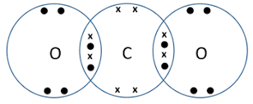
- Draw a dot and cross diagram to show the bonding in a molecule of carbon dioxide.

Read Now:
Covalent bonding takes place between non-metal atoms, where they share electrons to achieve a full outer shell and stable electron arrangement. Some covalent structures are molecules, which are small groups of non-metal atoms held together by strong covalent bonds. Some molecules can actually be very large, including one of the largest naturally-occurring molecules: DNA. Covalent bonding can also be found in giant covalent structures, such as diamond and graphite, which involve huge numbers of atoms covalently bonded to other atoms.
- Identify the type of elements between which covalent bonds are formed. Non-metals
- Explain why atoms make bonds. To achieve a stable electron arrangement/full outer shell
- Explain what is meant by a stable electron arrangement. A full outer shell
- Define a molecule. A group of non-metal atoms covalently bonded together.
- Give an example of a giant covalent structure. Diamond, graphite

Covalent bonding
What type of elements form covalent bonds? Non-metals
What happens to the electrons in a covalent bond? Shared between atoms
How many electrons are in one covalent bond? Two
Draw a dot and cross diagrssm for a molecule of
a) hydrogen
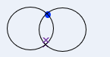
b) Chlorine
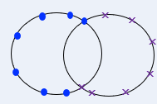
c) Hydrogen bromide (HBr)
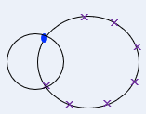
The structure of simple covalent substances
What simple covalent substances consist of? molecules

What holds the atoms together?covalent bonds
What holds the molecules together? Intermolecular forces
Give three names of simple covalent substances Hydrogen, Nitrogen, Fluorine, water, oxygen, bromine, chlorine, iodine.
Properties of covalent substances
Name the two types of covalent substances. Label the diagrams with the name of each.
Simple molecules and giant
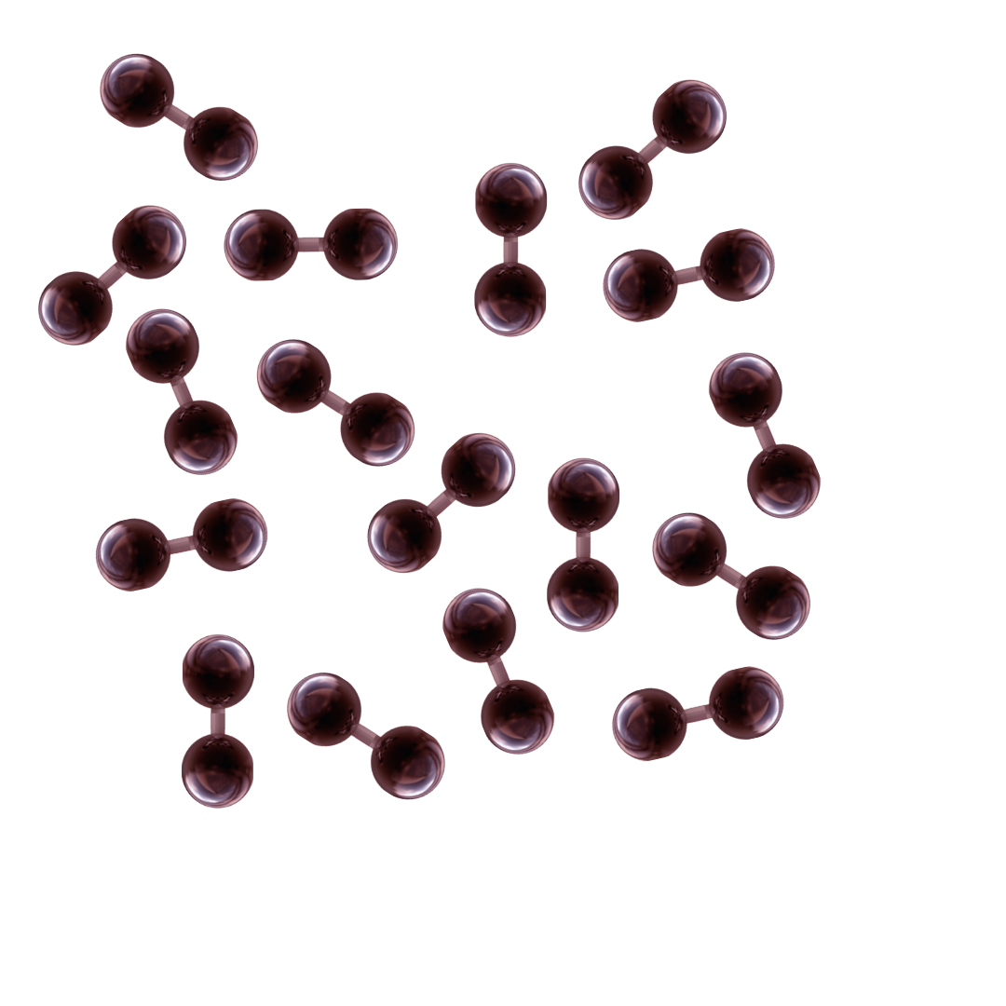
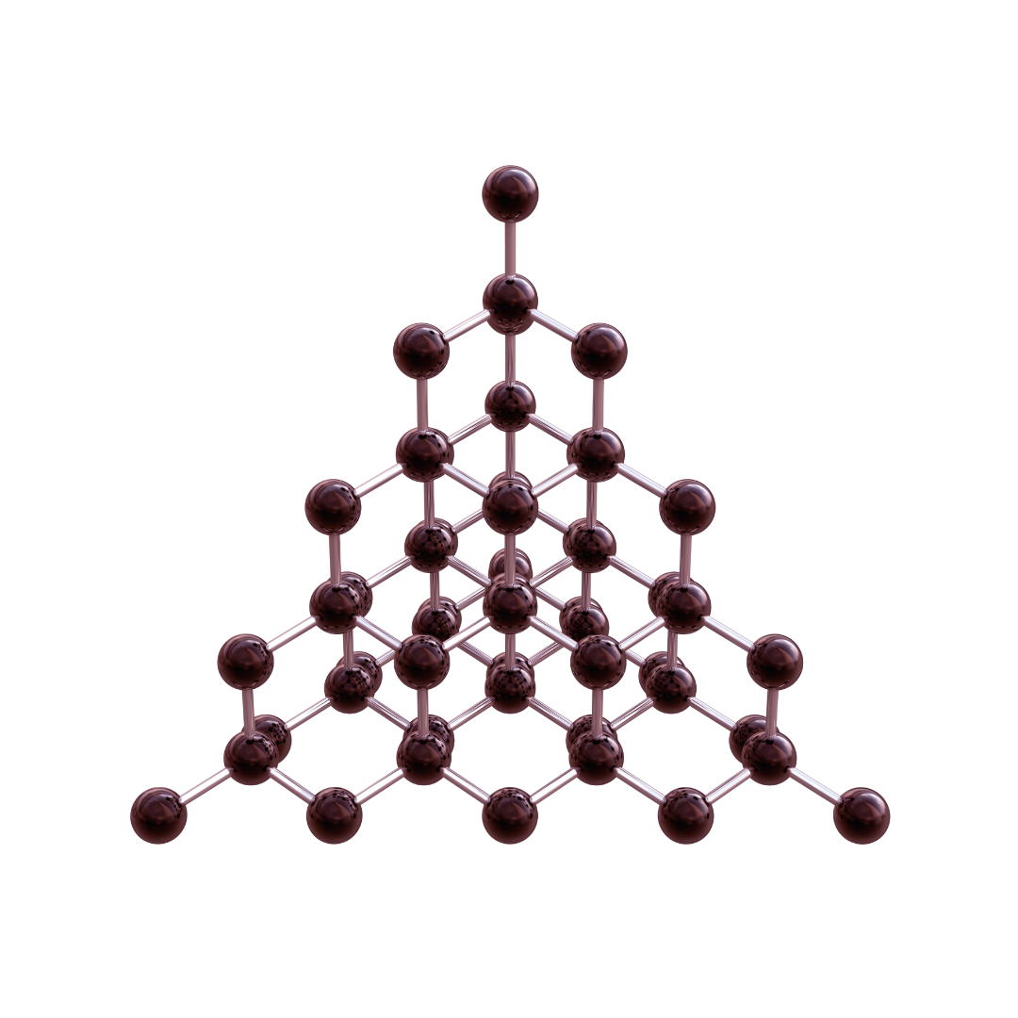

A: simple molecules B giant
For each statement write A or B or both or neither
1. Low melting and boiling point A
2. May conduct electricity B
3. Liquid or gas at room temperature A
4. Do not conduct electricity A
5. Solid at room temperature B
7. High melting and boiling point B
Drill

- What type of elements are bonded during covalent bonding? Non-metals
- What happens during covalent bonding? non-metals share pairs of electrons.
- How is a single covalent bond represented? by a single line, e.g. H-H
- How is a double covalent bond represented? by a double line, e.g. O=O
- What is a double covalent bond? 2 shared pairs of electrons
- What is the formula for methane? CH₄
- State one example of a simple covalent substance. Water, oxygen, and carbon dioxide
- What state of matter are simple covalent substances at room temperature? Liquid and gas
- Are covalent bonds weak or strong? Covalent bonds are strong
- Name the forces that act between molecules in a simple covalent substance. Intermolecular forces
- Explain the electrical conductivity of water. Water is a simple covalent substance. Its molecules are neutral and do not have any free electrons or ions to carry a charge. Therefore, water does not conduct electricity

I: Drawing covalent bonding diagrams
Use dot-and-cross diagrams to show the covalent bonding in a nitrogen molecule, N₂
Steps to Success
- Draw the electronic configuration of the reacting atoms using dots for one type of atom and crosses for the other. Only draw the valance shell.
- Count how many electrons each atom will need to share in order to get a full valance shell.
- Draw the atoms overlapping with any shared electrons in the middle

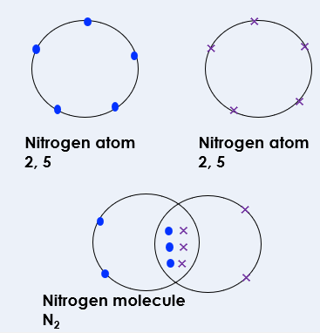

We: Drawing covalent bonding diagrams
Use dot-and-cross diagrams to show the covalent bonding in an oxygen molecule, O₂
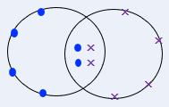

You: Drawing covalent bonding diagrams
Use dot-and-cross diagrams to show the covalent bonding in an ammonia molecule, NH₃

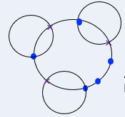

Exit Ticket
- Which answer correctly defines covalent bonding?
- A. Covalent bonding occurs where two or more non-metal atoms share pairs of electrons in order to achieve a stable electronic configuration
- B. Covalent bonding occurs where two or more metal atoms share pairs of electrons in order to achieve a stable electronic configuration
- C. Covalent bonding occurs where electrons are transferred from one atom to another in order to achieve a stable electronic configuration
How many pairs of electrons are shared, and how many covalent bonds are shown in this diagram?
- A. 4 pairs of electrons are shared, and there are two single covalent bonds
- B. 2 pairs of electrons are shared, and there are two double covalent bonds
- C. 4 pairs of electrons are shared, and there are two double covalent bonds
3. Why doesn’t pure water conduct electricity?
- A. It isn’t a solid
- B. Pure water does conduct electricity
- C. It does not contain any free electrons
Do Now
Crude Oil and Hydrocarbons

- State the type of elements that form covalent bonds. Non-metals
- Describe what happens to electrons when a covalent bond is formed. Electrons are shared between atoms to give each atom a full outer shell.
- Define a compound. Two or more elements chemically bonded together.
- Define a molecule. A group of non-metal atoms covalently bonded together.
- Calculate the relative formula mass of methane (CH4). C=12, H=1 16
Drill: Here are some common chemical formulae: CO2, H2O, O2, NaCl, Ca(OH)2.
1. Identify which of these formulae represent elements. O₂
2. Identify which of these formulae represent compounds. All except O₂
3. Identify which of these formulae would form molecules. CO₂, H₂O, O₂

Read Now:
Crude oil is one of the most important energy sources in the world and is used in many aspects of everyday life, from fuel and heating, to petrochemicals, tarmac for roads and plastics. Crude oil is a fossil fuel found deep underground rocks, so it is a finite or non-renewable resource. It is made of the remains of ancient biomass that lived and died millions of years ago. It is mainly from plankton, which was buried under many layers of mud. Crude oil itself is a mixture of different compounds called hydrocarbons. Crude oil is a very valuable resource, sometimes described as ‘liquid gold’ because it is so valuable. 5 countries are responsible for nearly half the global production of crude oil: the USA, Saudi Arabia, Russia, Iran and Canada.
- State how crude oil is used in everyday life. Fuel, heating, petrochemicals, tarmac, plastics
- Describe where crude oil is found. Deep underground rocks
- Describe what crude oil is made from. Remains of ancient biomass of plankton.
- Explain whether crude oil is a renewable or non-renewable resource. Non-renewable
- Name the countries that are the largest producers of crude oil. USA, Saudi Arabia, Russia, Iran and Canada

Crude Oil and Hydrocarbons
Give two uses of crude oil
Fuel, heating, making plastics, solvents, lubricant detergents
What type of resource is it? finite
IS crude oil an element, compound or mixture? mixture
Define hydrocarbon
Molecules made up of hydrogen and carbon atoms only.

Complete the table below

Name of alkane | Formula | Didplayed formula
Methane | CH₄ | 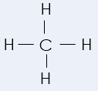
Ethane | C₂H₆ | 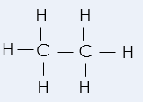
propane | C₃H₈ | 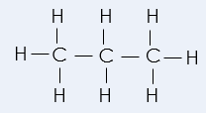
butane | C₄H₁₀ | 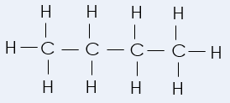

Drill
- Describe where crude oil is found. Answer: Deep underground under rocks.
- Describe what crude oil is made from. Answer: Ancient biomass (mainly plankton) that was buried in mud.
- Explain why crude oil is a mixture. Answer: It contains different compounds.
- Define a hydrocarbon. Answer: Molecules made of carbon and hydrogen atoms only.
- State the general formula of the alkanes. Answer: CnH2n+2
- Name the alkane with 1 carbon. Answer: Methane
- Name the alkane with 4 carbons. Answer: Butane
- Draw the displayed formula for the alkane with 3 carbons.
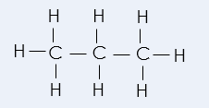

I: Alkane Formulae
We can use the general formula of alkanes to determine how many atoms are in a given molecule.
What is the general formula of the alkanes? C_{n}H_{2n+2}
How many hydrogen atoms would there be in an alkane with 5 carbons? C_{n}H_{2n+2,} n=5 2n + 2 (2x5) + 2 = 12 C₅H₁₂
How many carbon atoms would there be in an alkane with 14 hydrogens? C_{n}H_{2n+2} 2n + 2 = 14 2n = 12 n = 6 C₆H₁₄

We do: Alkane Formulae
How many hydrogen atoms would there be in an alkane with 8 carbons? 18
How many carbon atoms would there be in an alkane with 22 hydrogens? 10

You do: Alkane Formulae
How many hydrogen atoms would there be in an alkane with 12 carbons? 26
How many carbon atoms would there be in an alkane with 38 hydrogens?18

1. Which alkane is this?
Exit Ticket
  - A. Ethane
  - B. Propane
  - C. Butane
- An alkane has 15 carbons. How many hydrogen atoms would it have?
  - A. 30
  - B. 32
  - C. 34
- What is crude oil?
  - A. A finite resource formed from ancient plankton biomass
  - B. A finite resource formed from rocks
  - C. A finite resource containing compounds of carbon and water

Do Now
Fractional Distillation
- Define a hydrocarbon. A molecule made up of hydrogen and carbon atoms only.
- Name the alkane that contains four carbon atoms. Butane
- State the general formula of the alkanes. CnH2n+2
- Describe what happens when a covalent bond is formed. Electrons are shared so that each atom gets a full outer shell.
- Explain why covalent molecules have relatively low boiling points. There are weak intermolecular forces between molecules which require little energy to overcome.
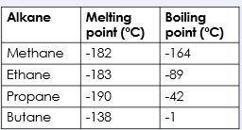
Drill:
The melting and boiling points of some of the alkanes are given in the table.

- Identify which state of matter these alkanes would be at room temperature (20 ºC). All gases
- Identify which state of matter these alkanes would be at -50ºC. Methane and ethane would be gases, propane and butane would be liquids.

Read Now:
Distillation is a method used to separate a mixture into the different compounds or elements within it based on their boiling points. For example, salt can be separated from sea water by distillation, as when it is heated the water will boil before the salt. The water vapour is then collected into a condenser where it cools down to form a pure liquid. Fractional distillation uses heating to separate the mixture of crude oil into its ‘fractions’, which are groups of different chemical compounds. Each of these fractions contains hydrocarbons of different lengths which are used for different functions. The shortest hydrocarbon molecules are used as gas fuels, while the longer hydrocarbon molecules are used for heavy fuel oil or bitumen for making tar for roads.
- State the physical property that distillation uses to separate mixtures. Boiling points
- Describe what happens during distillation. A mixture of liquids is heated. The liquid with the lower boiling point will evaporate first and then be separated using a condenser.
- Explain why crude oil is a mixture. It contains groups of chemical compounds.
- Explain what is meant by a ‘fraction’ of crude oil. A group of hydrocarbons with similar lengths.
- Give a use of the shorter hydrocarbon chains. Gas fuels

Fractional Distillation
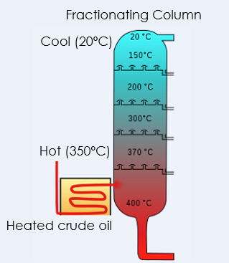
Fill in the key words in the method

Crude oil is heated and vaporises
The column is hottest/hotter_ at the bottoma and coolest/cooler at the top
The smaller molecules have lower boiling points, so they rise to the top of the column wheras larger molecules have a higher boiling point so styay at the bottom.
As the mixture rises it cools and condenses.
The vapours will consense at different temperatures because the hydrocarbons have different boiling points
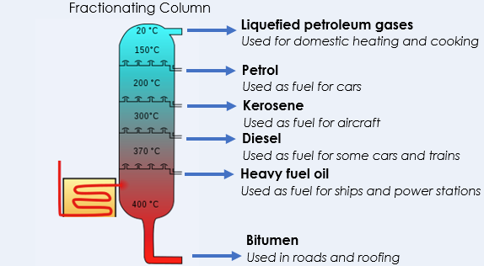

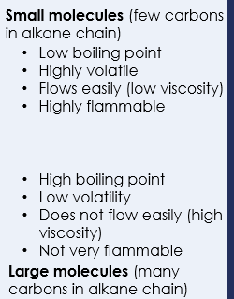

- Explain why crude oil is a mixture. It contains different compounds.
Drill
- Name the piece of equipment used to separate crude oil into fractions. Fractionating column.
- State the physical property that fractions are separated based on. Boiling point.
- Name the fraction with the smallest molecules. Liquefied petroleum gases.
- Name the fraction with the largest molecules. Bitumen.
- Give two fractions that are used as fuels for transport. Petrol, kerosene, diesel, heavy fuel oil.
- Describe the relationship between the size of molecules and boiling point. Boiling point increases with increasing molecule size.
- Explain the relationship between the size of molecules and boiling point. As molecules get larger, intermolecular forces between them increase, requiring more energy to overcome

I: Describe: to recall facts, events or processes in an accurate way
Describe how viscosity changes with increasing molecule size in fractions of crude oil.
- Fractions with larger molecules are more viscous than fractions with smaller molecules
- Viscosity increases with increasing molecule size

We: Describe how volatility changes with increasing molecule size in fractions of crude oil.
- Fractions with larger molecules are less volatile than fractions with smaller molecules
- Volatility decreases with increasing molecule size

You: Describe how boiling point changes with increasing molecule size in fractions of crude oil.
- Fractions with larger molecules have higher boiling points than fractions with smaller molecules
- Boiling point increases with increasing molecule size

Exit Ticket

- How does fractional distillation separate crude oil into fractions?
  - A. Each fraction has a different viscosity
  - B. Each fraction has a different melting point
  - C. Each fraction has a different boiling point
- Which fraction is used for producing material for roads?
  - A. Liquefied gases
  - B. Petrol
  - C. Bitumen
- Which best explains the pattern in boiling points of the alkanes?
  - A. As the alkanes get longer, boiling points increase because there are more atoms
  - B. As the alkanes get longer, boiling points decrease because they are more likely to be liquid
  - C. As the alkanes get longer, boiling points increase because the intermolecular forces increase

Combustion of Hydrocarbons
Do Now:
- Name the process used to separate crude oil. Fractional distillation
- Explain how this process separates crude oil. Hydrocarbons evaporate and condense at different temperatures depending on their boiling point.
- Describe the pattern of viscosity as hydrocarbon chains get longer. As hydrocarbon chains get longer, viscosity increases.
- Name the alkane that contains two carbon atoms. Ethane
- Explain the difference between an exothermic and an endothermic reaction. An exothermic reaction transfers energy to the surroundings whereas an endothermic reaction takes in energy from the surroundings.
Drill:
1. Name the compound with the formula CH4. Methane
2. Calculate the relative formula mass of propane. C=12, H=1 Mr = (12x2)+(6x1) = 30
3. Calculate the percentage by mass of carbon in ethane. % by mass = 24/30 x 100 = 80%

Read Now:
Many of the hydrocarbons in crude oil are used as fuels. A fuel is any substance that is burned to release energy. Combustion is the chemical reaction that takes place when a substance burns in air, so when hydrocarbons are burned, these are combustion reactions. These reactions are useful as they are highly exothermic, which means they transfer a large amount of energy to the surroundings. The main advantage of burning hydrocarbons is this release of energy, although there are also disadvantages. Combustion of hydrocarbons produces carbon dioxide as a product, which contributes to global warming. Scientists and companies are developing new fuels that are less harmful to the environment, but humans are still dependent on crude oil as a fuel source for heating homes, gas for cooking and fuel for cars and other modes of transport.
- Explain what is meant by a fuel. A substance that is burned to release energy.
- Explain what is meant by a combustion reaction. A reaction when a substance burns in air.
- Explain why combustion of hydrocarbons is a useful chemical reaction. It releases large amounts of energy.
- Give a disadvantage of burning hydrocarbons. It produces carbon dioxide.
- Describe two uses of hydrocarbons for humans. Fuel fot heating, gas for cooking and fuel for cars and transport.
Complete Combustion

Alkane + oxygen carbon dioxide + water

This reaction is exothermic
Incomplete Combustion
Incomplete combustion occus where there is a limited supply of oxygen
Incomplete combustion produces water, carbon monoxide and carbon
The toxic product of incomplete combustion is carbon monoxide
Incomplete combustion is less exothermic than complete combustion
IIf sulfur is present you may also get sulfur dioxide produced.

Balancing combustion equations
Always balance C, then H then O!

C₂H₆ + 3.5 O₂ 2 CO₂ + 3 H₂O

Number of atoms | Element | Number of atoms
 | C
 | H
 | O

Drill
- Name the substance that hydrocarbons react with during combustion. - Oxygen
- State the two products of combustion of hydrocarbons. - Water and carbon dioxide
- Identify which product is linked to global warming. - Carbon dioxide
- Explain the difference between complete and incomplete combustion. - Complete combustion happens when there is plenty of oxygen available whereas incomplete combustion occurs when there is not enough oxygen. Incomplete combustion produces carbon and carbon monoxide (and water) rather than carbon dioxide (and water).
- Describe how sulfur dioxide is formed. - Hydrocarbon fractions may contain sulfur impurities, which react with oxygen during combustion to form sulfur dioxide.
- State the environmental problem associated with sulfur dioxide. - Acid rain
- Explain which fractions of crude oil can be burned most easily. - The fractions with the shortest hydrocarbon chains as they are most flammable.

I: Combustion Reactions
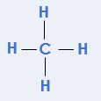
What is the chemical formula for methane? CH₄
Methane burns in air.
Draw the displayed formula for methane.
Write a word equation for the combustion of methane.
Methane + oxygen carbon dioxide + water
Write a symbol equation for the combustion of methane.
CH₄ + O₂ CO₂ + H₂O
Balance the symbol equation.
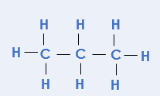
CH₄ + 2 O₂ CO₂ + 2 H₂O
We: Combustion Reactions
What is the chemical formula for propane? C₃H₈
Propane burns in air.
Drw the displayed formula for propane.

Write a word equation for the combustion of propane.
Propane + oxygen carbon dioxide + water
Write a symbol equation for the combustion of propane.
C₃H₈ + O₂ CO₂ + H₂O
Balance the symbol equation.
C₃H₈ + 5 O₂ 3 CO₂ + 4 H₂O
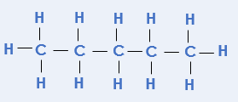
You: Combustion Reactions
Pentane (C₅H₁₂) burns in air.
Draw the displayed formula for pentane.
Write a word equation for the combustion of pentane.
Pentane + oxygen carbon dioxide + water

Write a symbol equation for the combustion of pentane.
C₅H₁₂ + O₂ CO₂ + H₂O

Balance the symbol equation. C₅H₁₂ + 8 O₂ 5 CO₂ + 6 H₂O

Exit Ticket

- Which is the correct general equation for the combustion of alkanes?
  - A. Alkane + water oxygen + carbon dioxide
  - B. Alkane + oxygen water + carbon dioxide
  - C. Alkane + air water + carbon dioxide
- Which is an advantage of burning hydrocarbons?
  - A. It releases lots of energy
  - B. It releases carbon dioxide
  - C. It releases water
- When does incomplete combustion take place?
  - A. If there is not enough oxygen
  - B. If there is not enough alkane
  - C. If there is not the same amount of alkane and oxygen

Do Now
Cracking
- State the general equation for the combustion of alkanes. Alkane + oxygen carbon dioxide + water
- Describe when incomplete combustion takes place. When there is a limited supply of oxygen.
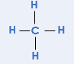
- Name the alkane with the chemical formula C2H6. Ethane
- Describe what short chain hydrocarbons are used for. As fuels for heating or cooking
- Draw the displayed formula for methane.

Drill
- Determine how many hydrogen atoms would be in an alkane with 14 carbon atoms. 30
- Determine how many hydrogen atoms would be in an alkane with 60 carbon atoms. 122
- Determine how many carbon atoms would be in an alkane with 104 hydrogen atoms. 51

Read Now:
According to a survey from 2022, there are about 1.45 billion cars in the world. That means that over 17 % of the human population has a car, but the cars are not spread evenly as some cars have many more cars than others. Many of these cars have petrol engines, which burn petrol as the fuel. Petrol contains relatively short chain hydrocarbons, such as octane (C₈H₁₈). As there is such high demand for these shorter hydrocarbons, some larger hydrocarbons can be broken down in chemical reactions to form these shorter chains. This type of chemical reaction is called cracking, and produces a shorter chain hydrocarbon as well as another type of hydrocarbon called an alkene. Alkenes are also useful for many different things, including making plastics.
- State how many cars there are in the world. 1.45 billion
- Name an alkane found in petrol. Octane
- Explain why there is high demand for petrol. Because it is used in cars and lots of people have cars.
- Describe what happens in a cracking reaction. Longer chain hydrocarbons are broken down in a chemical reaction to produce smaller chain hydrocarbons.
- Name the other type of product from a cracking reaction. Alkenes

Cracking
Small (er) molecules are in high demand as they are used as fuels
Cracking is breaking down larger hydrocarbon chains to form smaller chains
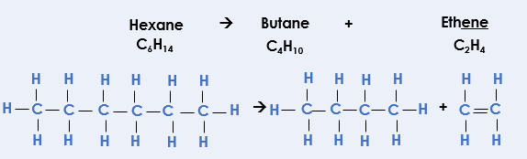

Cracking produces both alkanes and alkenes. These are different to alkanes
because they have at lease one C=C double bond_. We say alkenes are
unsaturated

To test for alkenes we can use bromine water.
If an alkene is present, it will turn from orange to colourless
The two types of cracking are steam and catalytic

Drill
- Explain the difference between supply and demand. Supply is how much of something is produced whereas demand is how much of something is needed.
- Describe what happens during cracking. A longer chain hydrocarbon is broken down to make a shorter chain hydrocarbon.
- Name the two types of product produced through cracking. A (shorter chain) alkane and an alkene.
- Give two reasons why cracking is useful. It increases supply of the smaller molecules used for fuels, and it produces alkenes which are used as feedstocks in the petrochemical industry.
- Describe what happens when bromine water is added to alkanes. Bromine water stays orange.
- Describe what happens when bromine water is added to alkenes. Bromine water turns colorless.
- Explain why alkenes are described as unsaturated. They contain a C=C double bond.
- Name two different methods of cracking. Catalytic cracking and steam cracking.
- Describe the conditions needed for catalytic cracking. A temperature of 550 ºC and a catalyst.
- Describe the conditions needed for steam cracking. A temperature of 850 ºC.
I: Determining the products of cracking
Dodecane (C₁₂H₂₆) is cracked to produce octane (C₈H₁₈).
C₁₂H₂₆ C₈H₁₈ + C₄H₈
What is the chemical formula for the other product formed? Write it on the lane
What homologous group does the other product belong to?_ Alkenes
Explain how you could tell the difference between the two products once they were separated.Add bromine water to each. Octane will cause the bromine water to stay orange and the alkene will turn the bromine water colourless.
Explain why it is useful to crack dodecane.There is greater demand for shorter molecules like octane, as they can be used as fuels.
We: Determining the products of cracking
Dodecane (C₁₂H₂₆) is cracked to produce heptane (C₇H₁₆).
C₁₂H₂₆ C₇H₁₆ + C₃H₆
What is the chemical formula for the other product formed? Write it on the lane
What homologous group does the other product belong to?_ Alkenes

Explain how you could tell the difference between the two products once they were separated.Add bromine water to each. Heptane will cause the bromine water to stay orange and the alkene will turn the bromine water colourless.
Explain why it is useful to crack dodecane.There is greater demand for shorter molecules like heptane, as they can be used as fuels.

You: Determining the products of cracking
Octane (C₈H₁₈) is cracked to produce hexane (C₆H₁₄).
C₈H₁₈ C₆H₁₄ + C₂H₄
What homologous group does the other product belong to?_ Alkenes
Explan how you could tell the difference between the two products once they were separated.Add bromine water to each. Hexane will cause the bromine water to stay orange and the alkene will turn the bromine water colourless.
Explain why it is useful to crack octane.There is greater demand for shorter molecules like hexane, as they can be used as fuels.

Mark it: Looking at a student exam answer
1. Read the question and the student’s answer carefully.
2. Use the mark scheme to award the student a number of marks and annotate their answer with suggestions to improve.
Stretch: Rewrite the answer to show how it should be done!
Question: The table below gives some information about some of the fractions in crude oil.
Fraction | Length of hydrocarbons (number of carbon atoms) | % in crude oil | % demand
Gas | 1-4 | 3 | 14
Petrol | 5-8 | 7 | 26
Kerosene | 9-15 | 12 | 18
Diesel | 16-24 | 24 | 20
Bitumen | >25 | 54 | 22
- The quantity of each fraction can be changed by cracking.
Describe what happens when a hydrocarbon is cracked and the conditions required.
(4)
- Use information from the table to explain why cracking is useful. (3)
Student answer:
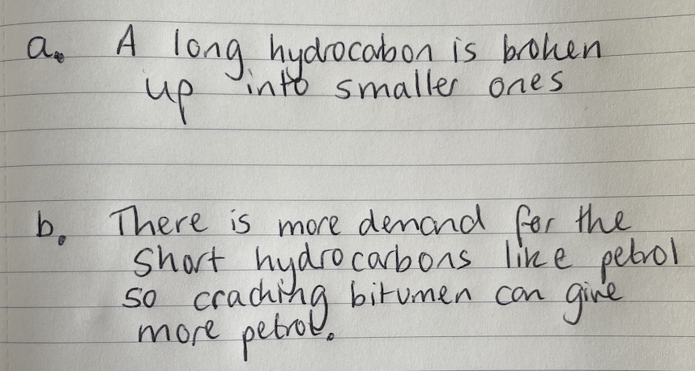

Marks awarded= _______
Mark scheme:
Point | Mark
Long/large hydrocarbon chains are broken down | 1
Into shorter chain hydrocarbons (alkanes) | 1
And alkenes | 1
A high temperature or catalyst is required | 1

Point | Mark
There is higher demand than supply of short chains (from crude oil) | 1
So cracking can increase the supply of short chain hydrocarbons | 1
Named example,  e.g. only 7% of crude oil is petrol but it is over a quarter of the demand, so producing more petrol through cracking can meet this demand | 1

Exit Ticket
- Which explains why cracking is useful?
  - A. It increases demand for shorter hydrocarbon chains
  - B. It increases supply of shorter hydrocarbon chains
  - C. It separates crude oil into different useful fractions
- What is the formula of the other product of this cracking reaction?
C₁₀H₂₂ C₈H₁₈ + ________
  - A. C₂H₄
  - B. C₂H₆
  - C. C₁₈H₄₀
- What is the difference between alkanes and alkenes?
  - A. Alkanes have a C=C double bond
  - B. Alkenes have a C=C double bond
  - C. Alkenes contain more hydrogen atoms

Do Now:
Polymers
- Define a hydrocarbon. A compound that contains carbon and hydrogen atoms only.
- Name the type of bonding found in hydrocarbons. Covalent.
- State the general formula of the alkanes. CnH2n+2.
- Describe how fractional distillation is used to separate crude oil. Crude oil is heated and hydrocarbons are evaporated. Then condense at different temperatures depending on their boiling points.
- Explain the difference between reusing and recycling. Reusing involves using the same product again, but recycling involves a process of making the materials from the product into something else.
Drill
- Describe the structure of diamond. In diamond, each carbon atom is covalently bonded to four other carbon atoms in a giant covalent network.
- Describe the structure of graphite. In graphite, each carbon atom is covalently bonded to three other carbon atoms in a giant covalent network, and arranged in layers, leaving a free electron from each carbon atom.
- Explain why graphite conducts electricity but diamond does not. Graphite contains free electrons to carry the charge through the structure, but diamond does not.
:
Read Now:
The word polymer comes from Greek and means ‘many parts’. A polymer is a very long molecule made up of many units. Polymers can be naturally occurring or synthetic (man-made) and we use many examples in our daily lives. One of the most important naturally occurring polymers is DNA, which is found in the nuclei of all our cells. Other naturally occurring polymers are proteins and starch. These naturally occurring polymers make up an important part of our diet, but they must be digested into small soluble products before being absorbed into our blood stream. Products made from synthetic polymers are all around us, including plastic products, silicone products, nylon and polyester clothing.
- Define a polymer. A long molecule made up of many units
- Define synthetic. Man-made
- Give three examples of naturally occurring polymers. DNA, starch, proteins, cellulose
- Explain why naturally occurring polymers found in foods must be digested. Polymers are too large and insoluble to be absorbed into the bloodstream.
- Give an example of a synthetic polymer. Nylon, silicone, plastic, polyester

Polymer


Properties of polymers
The properties of a polymer depend on two things:
- the -monomer it is made from
- the conditions that the polymer is made in

Complete the table for thermosetting sand thermosoftening plastics
 | 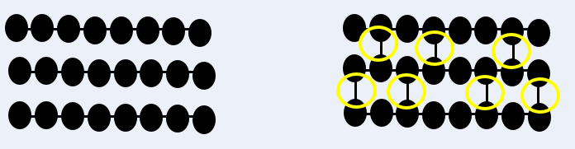
Type of polymer | Thermosoftening | Thermosetting
What happens when heated? | Melts | Do not melt
Are there intermolecular forces between the polymer chains? | Yes | Yes
Are there crosslinks (covalnt bonds) between the chains when heated? | No | Yes
Are they suitable for recycling? | Yes | No

Drill
- What is a polymer? Long chain molecules made of many units
- What kind of bonding occurs between monomers in a polymer? Covalent bonding
- What does the n represent in the general formula for a polymer? n represents the number of repeating units of the polymer
- Name the forces that act between the polymer molecules. Intermolecular forces act between the polymer molecules
- State whether these forces are weak or strong. These forces are relatively strong
- Describe the state of polymers at room temperature. Polymers are solids at room temperature
- What determines the properties of polymers? The properties of polymers are determined by the monomers that make them up and the conditions that they are made in
- What happens to thermosetting polymers when heated? Thermosetting polymers do not melt when heated
- What happens to thermosoftening polymers when heated? Thermosoftening polymers melt when heated
- Explain why these polymers behave differently when heated. Thermosetting polymers contain crosslinks, which are covalent bonds between molecules. These require much more energy to overcome, so they have much higher melting points

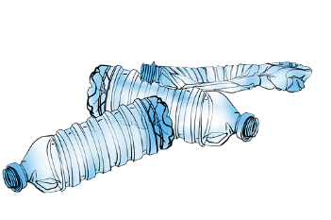
We: Explain: to use scientific understanding to make something clear or state the reason for something happening
Many recyclable plastic bottles are made from thermosoftening polymers.
Explain how the properties of a thermosoftening polymer make them suitable for recycling.

- Thermosoftening polymers contain weak intermolecular forces between molecules
- These do not require a lot of energy to overcome, so thermosoftening polymers have low melting points and melt when heated
- This means they can be melted and reshaped to be recycled into other products

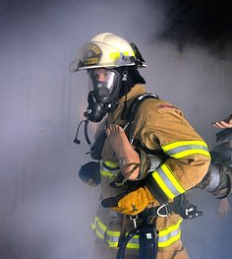
You: Explain: to use scientific understanding to make something clear or state the reason for something happening
Firefighters’ helmets are made from thermosetting polymers.
Explain how the properties of a thermosetting polymer make them suitable for this purpose
- Thermosetting polymers contain crosslinks, which are covalent bonds between molecules
- These require a lot of energy to overcome, so thermosetting polymers have high melting points and do not melt when heated
- This means they will not melt when exposed to high temperatures
Exit Ticket

- How many carbon atoms will the polymer represented by this diagram have?
  - A. 20
  - B. 40
  - C. 80
- What is between polymer molecules?
  - A. Covalent bonds
  - B. Intermolecular forces
  - C. Electrostatic attraction
- What is the difference between thermosetting and thermosoftening polymers?
  - A. Thermosoftening polymers melt when heated
  - B. Thermosetting polymers melt when heated
  - C. Thermosoftening polymers contain crosslinks

Independent Practice

Prior Knowledge Review 39
Crude oil and hydrocarbons 41
Fractional Distillation 45
Combustion of Hydrocarbons 48
Cracking 52
Polymers 56

Prior Knowledge Review
Section A
- Choose the correct words from the box to complete the sentence.

You can use each work once, more than once or not at all.

elements metals non-metals ions

Covalent bonding occurs between non-metals and non-metals

- Complete the electronic configuration diagram below to show 6 electrons on the outer shell.

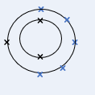

- Redraw the electronic configuration from question 2 above, but this time
- Only draw the valance shell electrons
- Draw the atom with a full outer shell
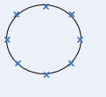
- Complete the dot and cross diagram to show the bonding in a molecule of Chlorine gas, Cl₂.

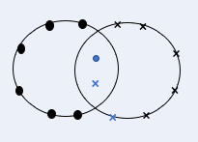

Section B
- Draw a dot-and-cross diagram to show the bonding in a molecule of water, H₂O.
- Draw a dot-and-cross diagram to show the bonding in a molecule of methane, CH₄.
- Draw a dot-and-cross diagram to show the bonding in a molecule of ammonia, NH₃.

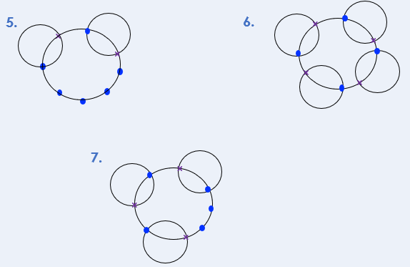

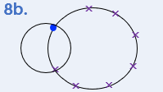
Section C
- Hydrochloric acid has the chemical formula HCl.
- Identify the type of bonding present in HCl. . Covalent bonding
- Draw a dot-and-cross diagram to show the bonding in HCl.
- Calculate the relative formula mass of hydrochloric acid. 1+35.5 = 36.5
- Calculate the percentage by mass of chlorine in HCl. Mass of element/mass of compound x 100 = 35.5/36.5 x 100 = 97.26%
- Write a word equation to show what happens in the reaction between hydrochloric acid and sodium hydroxide. Hydrochloric acid + sodium hydroxide sodium chloride + water
- Write a balanced chemical equation for the reaction in Q5. HCl + NaOH NaCl + H₂O
- Identify the type of bonding that would be present in each of the products of the reaction in Q5. Water: covalent, sodium chloride: ionic

Crude oil and hydrocarbons
Section A
- Choose the correct words from the box to complete the sentences.

Crude oil is a finite resource found deep underground. It is made from the biomass of ancient plankton, which was buried under mud.

compound mixture hydrocarbons mud plankton rocks finite infinite

- Choose the correct definition of a hydrocarbon.
Tick ( ) one box.
- A compound made of hydrogen and carbon atoms
- A compound made of water and carbon atoms
- A mixture made of hydrogen and carbon atoms
- A mixture made of water and carbon atoms
- State the general formula of the alkanes. C_{n}H_{2n+2}

- Choose the name of the alkane that contains three carbon atoms.
Tick ( ) one box.
- Ethane
- Propane
- Butane
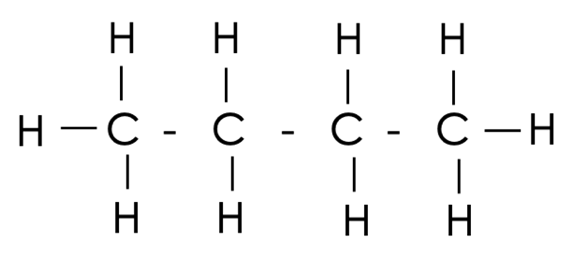
- Name the alkane shown by the structural formula below. butane

Section B
- Methane and ethane are both alkanes.
- Draw the structural formulae for methane and ethane.
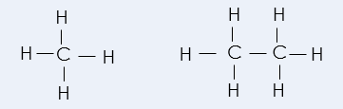
- Complete the dot and cross diagram to show the bonding in a molecule of ethane.
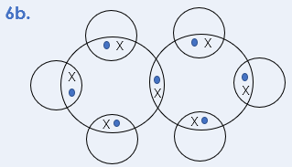
- Compare the structures of methane and ethane.
- Both are alkanes
- Both are hydrocarbons/contain only carbon and hydrogen atoms
- Both contain covalent bonds
- Methane has 1 carbon atom, ethane has 2 carbon atoms
- Methane has 4 carbon atoms, ethane has 6 carbon atoms
- Ethane also contains a carbon-carbon bond, but methane only has carbon-hydrogen bonds

- The alkanes is a large family of compounds.
Determine the chemical formula of an alkane with:
- 8 carbons C₈H₁₈
- 24 carbons C₂₄H₅₀
- 36 hydrogens C₁₇H₃₆
- 20 hydrogens C₉H₂₀

- The image below shows a model of an alkane.
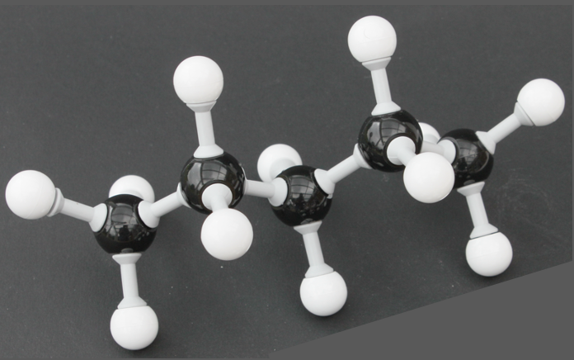

A

- Determine the chemical formula of this alkane. C₅H₁₂

- Give an advantage of this model.
It shows the shape of the molecule in 3D. The bonds are not really at 90º to each other.
- What is represented by the letter A? A covalent bond

- Explain why this alkane is a compound and a molecule.
It contains two different types of atom (elements) chemically bonded together and the atoms are non-metals covalently bonded together

Section C

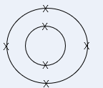
- Carbon has an atomic number of 6 and a mass number of 12.

- State the number of protons, neutrons and electrons in an atom of carbon. 6 protons, 6 neutrons, 6 electrons
- Draw the electronic configuration of a carbon atom.
- Explain why a carbon atom is neutral. It contains the same number of (positively charged) protons and (negatively charged) electrons.
- Carbon’s mass number is usually rounded to 12 but the relative atomic mass is actually 12.02. Explain why this is not a whole number. It contains the same number of (positively charged) protons and (negatively charged) electrons.
- Compare the atomic structures of carbon-12 and carbon-14. Both types of carbon atom contain 6 protons but carbon-12 contains 6 neutrons and carbon-14 contains 8 neutrons.

Fractional Distillation
Section A
- Explain why crude oil is described as a mixture.

. It is made up of different compounds, which are not chemically bonded together.
- Choose the fraction of crude oil that has the lowest boiling point.
Tick ( ) one box.
- Bitumen
- Petrol
- Liquefied petroleum gases

- Choose the option that correctly describes the pattern of viscosity in the fractions of crude oil.
Tick ( ) one box.
- Viscosity increases as the size of molecules in a fraction increase
- Viscosity decreases as the size of molecules in a fraction increase
- Viscosity increases as the size of molecules in a fraction decrease

- The image below shows a fractionating column.
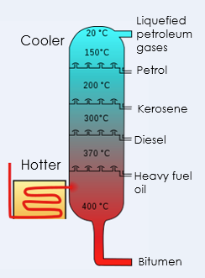

- Add labels to the fractionating column to show where it is hottest and coolest.

- Add labels to the fractionating column to name each of the fractions collected at each condenser.

Section B
- Fractional distillation is used to separate crude oil.
- Describe how fractional distillation separates crude oil.

- Crude oil is heated
- Hydrocarbons evaporate
- The column is hotter at the top (so hydrocarbons cool as they get higher up)
- Fractions cool and condense
- Fractions condense at their boiling point (at different heights in the column)

- Describe the relationship between the size of molecules in a fraction and boiling point.

Boiling point increases as the size of molecules in a fraction increases

- Explain the relationship between the size of molecules in a fraction and boiling point.

As molecules get larger, intermolecular forces increase so they require more energy to overcome.

- The table below shows the boiling points of three alkanes.

Alkane | Boiling point (ºC)
Pentane (C₅H₁₂) | 36
Decane (C₁₀H₂₂) | 174
Pentadecane (C₁₅H₂₂) | 271

- What is an alkane?
A compound that contains only hydrogen and carbon atoms, and only single bonds (is saturated)

- What is the general formula for alkanes? C_{n}H_{2n+2}

- Determine which state of matter pentane would be at room temperature (22 ºC). Liquid

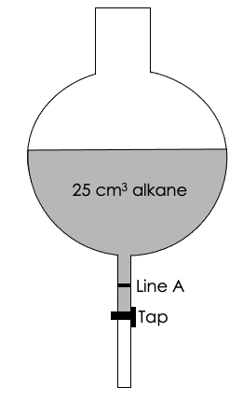
A student used the following experiment to investigate a property of these alkanes:
- Add 25 cm³ of pentane to a separating flask (as shown)
- Start the timer as the tap is opened
- Record the time taken for the level of pentane to reach line A
- Repeat for decane and pentadecane

- What property is the student investigating with this experiment?
Viscosity
- The student measured 5.2 seconds for pentane to reach line A.
Predict how the time taken for decane and pentadecane would compare.
Explain your answer.

Decane would take longer than pentane and pentadecane would take longer than decane.
Because the larger the molecule, the more viscous the liquid and the longer it will take to be poured.

Section C

- Fractional distillation is used to separate crude oil into fractions, but there are many other uses of distillation.

- Describe how distillation is used in desalination. 7a. Saltwater is heated, so water is evaporated and condensed, leaving the salt behind.
- Give a disadvantage of using distillation for desalination. 7b. It requires a large volume of saltwater to be evaporated, which requires a lot of energy so would be very expensive.
- Give the name for water that is safe to drink. 7c. Potable water

- Explain the difference between water that is safe to drink and distilled water. 7d. Potable water may contain dissolved ions and other substances, but distilled water is pure water.

- Explain whether distilled water would conduct electricity. 7e. Pure water would not conduct electricity as it is covalently bonded so there are no free electrons (or dissolved ions) to carry charge.

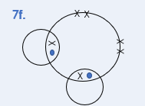
- Draw a dot and cross diagram to show the bonding in water.

- Calculate the percentage by mass of oxygen in water.
$$\% by mass=\frac{mass of element}{mass of compound} ×100$$
$$\% by mass=\frac{16}{18} ×100$$
$$\% by mass=88.89 \%$$

Combustion of Hydrocarbons
Section A

- Choose the correct definition of a hydrocarbon.
Tick ( ) one box.
- A molecule that contains carbon and water atoms only
- A molecule that contains carbon and hydrogen atoms only
- A molecule that contains a mixture of carbon and hydrogen atoms
- Complete the chemical formula for propane. C₃H₈
- Choose the substance that hydrocarbons react with during combustion.
Tick ( ) one box.
- Air
- Oxygen
- Carbon dioxide

- Complete the general equation for the complete combustion of alkanes:
Alkane + oxygen carbon dioxide + water
- Describe what is needed for complete combustion of alkanes to take place.
A good supply of oxygen/air

Section B

- Methane is a common hydrocarbon that is used as a domestic fuel.

- Write a balanced symbol equation for the complete combustion of methane.
CH₄ + 2 O₂ CO₂ + 2 H₂O
- Explain why the incomplete combustion of methane may be dangerous.
It produces carbon monoxide, which is poisonous/toxic/stops oxygen binding to haemoglobin in blood.
- Complete the reaction profile for the combustion of methane.

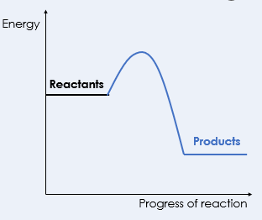

- Explain your answer to question c.
It is exothermic, so the reactants have more energy than the products.

- Petrol is used as a fuel in many cars. One of the compounds in petrol is octane (C₈H₁₈).
- Complete the word equation for the reaction of octane that takes place in a car engine:

Octane + oxygen carbon dioxide + water
- Cars should use sulfur-free petrol. Explain why.

Sulfur impurities react with oxygen to form sulfur dioxide, which leads to acid rain.
- Many scientists are concerned about one of the products of the complete combustion reaction of octane in car engines. Identify the product that is concerning scientists and explain why it is a concern.

Carbon dioxide, as it is contributing to global warming
The table below provides data on the composition of gases from the exhaust of a petrol engine.
Gas | Percentage
Nitrogen | 67
Carbon dioxide | 16
Carbon monoxide | 1.5
Oxygen | 0.5
Nitrogen oxides | 0.15
Sulfur dioxide | 0.02
Other gases
- Calculate the percentage of other gases present. 14.83%

- Name the compound that makes up most of the other gases. Water (vapour)/steam

Section C
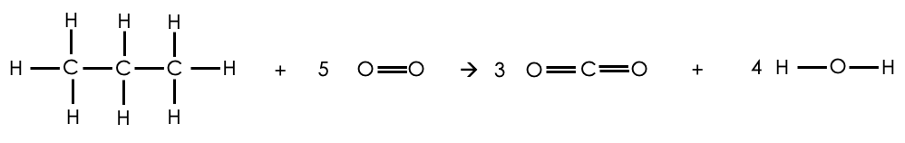
- Below shows the reaction between propane and oxygen. This reaction is exothermic as 2018 kJ/mol more energy is released when forming the bonds than is taken in to break the bonds in the reactants.

Bond | Bond Energy (kJ/mol)
C-H | 413
O=O | 498
C=O | 799
O-H | 464

- Use the information given to calculate the C-C bond energy.
Energy change = 2018 kJ/mol
Energy change = In-Out
In:
2$x$+(8x413)+(5x498) = 5794 + 2$x$
Out:
(6x799)+(8x464) = 8506
Energy change = In-Out
2018 = In - 8506
In = (-)6488
5794 + 2$x$ = 6488
2$x$ = 694
$x$= 347 (kJ/mol)
- Calculate the mass of carbon dioxide that would be made when 100 g of propane burns in 600 g of oxygen.
Relative atomic masses:
Carbon = 12
Hydrogen = 1
Oxygen = 16
$$Number of moles C3H8= \frac{mass}{Mr} Number of moles C3H8= \frac{100}{44} Number of moles=2.2727… mol$$
$Number of moles O2= \frac{mass}{Mr}$ $Number of moles O2= \frac{600}{32} Number of moles=18.75… mol$
Mole ratio = 1:5 $number of moles of O2 needed to react with 2.2727 mol of C3H8=11..36 mol$ (possible)
$number of moles of C3H8 needed to react with 18.75 mol of O2=3.75 mol$(not possible)
Limiting reactant = C₃H₈
Mole ratio = 1:3 $Number of moles CO2=6.8181… mol Number of moles CO2= \frac{mass}{Mr}$
$$6.8181… mol= \frac{mass}{44} Mass=300 g$$
Cracking
Section A
- Describe what happens when large hydrocarbon molecules are cracked.
They are broken down to form shorter chain hydrocarbons and alkenes.
- Choose which of these is an alkene.
Tick ( ) one box.
- Ethane
- Ethene
- Propane

- Give one difference between alkanes and alkenes.
Any one from:
- Alkenes are unsaturated, alkanes are saturated
- Alkenes contain a C=C double bond
- Alkanes only contain C-C single bonds
- Alkanes have the general formula C_{n}H_{2n+2}
- Alkenes have the general formula C_{n}H_{2n}

- What type of reaction is cracking?
Tick ( ) one box.
- Combustion
- Neutralisation
- Decomposition

- The chemical equations below show some of the reactants and products of different cracking reactions.
- Determine the formula of the missing product in each case.

- C₁₀H₂₂ C₆H₁₄ + C₄H₈

- C₆H₁₄ C₂H₄ + C₄H₁₀

- C₁₄H₃₀ C₈H₁₈ + C₆H₁₂

- Highlight all alkanes in one colour and all alkenes in another colour.

Section B
- Crude oil is fractionally distilled. Fractions with larger molecules can then be cracked.
Describe two differences between fractional distillation and cracking.
Any two from:
- cracking uses a catalyst, fractional distillation doesn’t
- cracking breaks up molecules, fractional distillation separates them
- cracking is a chemical reaction, fractional distillation is a physical process

- Decane (C₁₀H₂₂) is commonly cracked.

- Determine the formula of the other product formed when decane is cracked.

C₁₀H₂₂ C₂H₄ + C₈H₁₈
- Name the product with the formula C₂H₄. Ethene

- C₂H₄ is an alkene. Explain how this could be tested. Bromine water could be added to it, which would turn colourless.

- Give two conditions used for cracking decane. Any two from:
High temperature
Steam
Catalyst (accept zeolite, aluminium oxide)

- The table below gives some information about fractions of crude oil.

Fraction | Approximate % of crude oil | Approximate % of total demand
LPG | 4 | 6
Petrol | 10 | 25
Kerosene | 16 | 14
Diesel | 20 | 20
Heavy fuel oil | 22 % | 18
Bitumen/residue | 28 | 17

- What does LPG stand for? Liquefied petroleum gases

- Complete the table by naming the missing fraction and calculating the approximate percentage of crude oil that is made up of heavy fuel oil.

- Identify which of these fractions is the most flammable. LPG/liquefied petroleum gases

- Use the information in the table to explain why it is useful to crack hydrocarbons.

To break longer chains into smaller chains where the demand is higher. For example, only 10% of crude oil is petrol but the demand for petrol is 25% of the total.

- The diagram below shows a chemical reaction.
Compound C
Compound B
Compound A
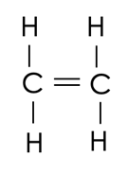
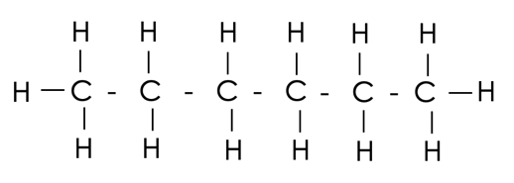
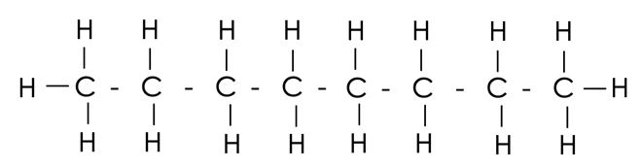

+

- Compounds A, B and C are all what type of compound? Hydrocarbons
- What type of chemical reaction is shown by this diagram? Cracking
- Suggest one use for Compound BFuel/petrol

- Suggest one use for Compound CFeedstock for petrochemical industry/chemical reactions, for making plastics/polymers
Section C

- Cracking is used to break long hydrocarbon chains into smaller hydrocarbon chains.
- Cracking takes place under high temperatures. Explain whether cracking is an exothermic or endothermic reaction. It involves thermal decomposition, which is an endothermic reaction. More energy is taken in from the surroundings than is released through the reaction, which is why it has to take place at high temperatures.
- (HT) C₂₀H₄₂ can be cracked. The equation for the reaction is:
C₂₀H₄₂ C₁₆H₃₄ + 2 C₂H₄
Calculate the mass of C₂₀H₄₂ needed to produce 40 kg of ethene.
Relative atomic masses:
C=12
H=1
$$Number of moles C2H4= \frac{mass}{Mr} Number of moles C2H4= \frac{40 000}{28}$$
$Number of moles=1 428.57… mol$Mole ratio = 1:2
$$Number of moles C20H42=714.2857… mol Number of moles C20H42= \frac{mass}{Mr}$$
$714.2857… mol= \frac{mass}{282} Mass=201 428.57 g$Mass = 201.43 kg

Polymers
Section A
- What is the definition of a polymer?
Tick ( ) one box.
- Repeating units that join together to make a long chain
- Small molecules held together by intermolecular forces
- A long molecule made up of many repeating units
- Give the name for repeating units that polymers are made from. Monomer(s)

- What polymer would be made from repeating units of ethene?
Tick ( ) one box.
- poly(propene)
- poly(ethene)
- poly(ethane)

- Look at the diagram representing a polymer below.
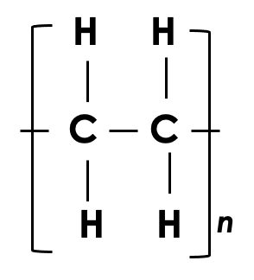

- What does the single straight line in between the H and C represent? A covalent bond
- What does the ‘n’ represent?The number of repeating units in the polymer molecule

Section B
- What type of bonds are there in a polymer chain? Covalent

- Describe the forces that occur between polymer chains. There are (weak) intermolecular forces between polymer chains
- What type of polymers melt when heated? Thermosoftening polymers
- Draw the molecular formula for a polymer molecule with 50 carbon atoms.
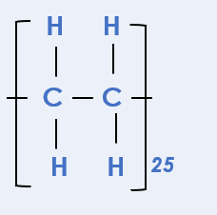
- Explain why thermosetting polymers are suitable as a material for a saucepan handle.
Thermosetting polymers do not melt when they are heated, so when the saucepan heats up the handle would not melt.
- Thermosoftening polymers are used to make plastic bottles and food packing. Explain why thermosoftening polymers would not be suitable for storing hot food.
Thermosoftening polymers melt when they are heated, so if hot food was placed in them, they would melt.

- The diagrams below show models for the structures of a thermosetting polymer and a thermosoftening polymer. Identify which is which and explain why. 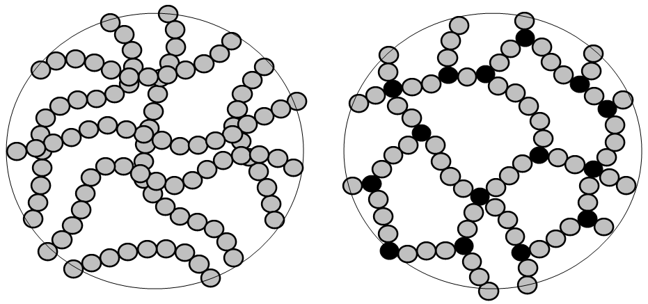
Image from Wikimedia
A is thermosoftening, B is thermosetting
B contains crosslinks, which are covalent bonds between the polymer chains

Section C
- Carbon dioxide and diamond both contain carbon.

- Describe the bonding in carbon dioxide. In carbon dioxide, there is one carbon atom that makes two covalent bonds (a double bond) with each oxygen atom, sharing electrons so that all atoms have a full outer shell.
- Describe the bonding in diamond. In diamond, each carbon atom is covalently bonded to four other carbon atoms in a giant covalent network.
- Explain why carbon dioxide is a gas at room temperature but diamond is a solid
There are weak intermolecular forces between molecules of carbon dioxide, which can be easily overcome, so it has a low melting and boiling point.
A great deal of energy would be needed to overcome the many strong covalent bonds in diamond, so it has a very high melting and boiling point.

